**CS 419 Compiler Projects Form**

**1)Instructions to be Followed (for the Hard Copy):**

**I.** Fill page **NO 4** with the required Fields:

**I.** Project Idea: The **Idea** will be assigned to you .II. Team Members NO#: Number of team members **7** III. Table:

* ID: Your FCIH ID.
* Name: Your **Full Name** as registered on College’s Database. - Level & Department: Your **(Current)** level and department.
* Section(Day-from-to): Your Section Day and time slot.
* Role: Your role in project (**Team leader** OR **Member**).
* Fill Page **NO 5 & 6** with your (**Regular Expressions**, **Finite automata**, **Parse trees** and **abstract syntax tree**) respectively.

1. **Minus Policies:**

I. **Project Policy:** affects all projects members including team leader.II. **Member Policy:** affects a member of project’s members.

1. **General Notes:** 
   1. Total grade of Project is 15
   2. **Deadline** to register yourself and your team on online form **Tuesday 05/04/2022 at 11:59 PM** after that **-2 Project Policy** will be applied**.**
   3. Once you Registered, **NO modifications** will be done.
   4. Allowed only on registration for team in form, duplication will got **-2 Project Policy.**
   5. Each group will be assigned **an Idea, ID and time slot** for **discussion**. VI. Each team member and team leader in a team **must work in project’s coding phase** (including implementation of **finite automata and parse trees**).

1. **Discussion Notes:**
   1. **Copied Code** will be got ZERO Without Discussion.
   2. By references to Section 3 (General notes) Point V , **-5 Member policy** will be applied to each team member (including team leader) who does not participate in project coding phase **as well as the team leader who does not report this case**.
   3. Each team member must have **a complete knowledge** about the whole project
   4. **Evaluation** will be **Individual Evaluation** not project Evaluation.
   5. **-2 Project Policy** will be applied in case of being late for assigned discussion time slot
   6. **NO discussion will be repeated under any circumstances.**
   7. At Discussion day, in case of offline discussions, each team must have **Hard Copy form** including (**Finite automata and parse trees of team’s project**).
   8. Discussion Day will be **sent later** .

1. **Notes about Implementation:** 
   1. **.Net or PHP** are only allowed.
   2. The project must be a Web (use latest technologies).
   3. Your code must be uploaded to github before discussion.
   4. **- 5 Project policy** will be applied in case of using **Built-in Method** within implementation of the scanner or parser, you must create your **own methods to match** for ex (your regular Expressions).
   5. Each Project must contain a full functional editor (comment, uncomment, put red line under wrong words, auto complete, navigation to function or class, line NO).
   6. Each Project must contain **two buttons** , one button called “**Scan**” to run scanner and other called “**Parse**” to run parser –parser must take output of scanner to do it’s task.
   7. Each project must contain a button named “**Browse**” that allows us to choose a **file from a disk** that allows us to parse or scan this file **Without Showing what is inside the file** and shows the output.
   8. – 3 Project policy will be applied if the content of the file that is mentioned in point V is opened or viewed.

**5) Notes about Discussion Testing:**

There will be two types of Testing :

1. **White Box Testing:** This will be from **Editor**.
2. **Black Box Testing:** This will be from “**Browse**” Button

**Thanks,**

**CS 419 Compiler**

**Project Form**

**Project Idea:**

Project No#2

**Team Members NO#:** 14

|  |  |  |  |  |  |
| --- | --- | --- | --- | --- | --- |
| **ID** | **Name** | **Level& Department** | **Section(Dayfrom-to)** | **Role (Lead/Member)** | **Grade** |
| 201900217 | باكينام حسام فاروق اسماعيل | Level 3  CS | Wednesday  12-2 | Lead |  |
| 201900182 | أميرة علاءالدين عبدالله عبدالخالق | Level 3  CS | Wednesday  12-2 | Member |  |
| 201900206 | ايمان محمد محمود عبد الحميد | Level 3  CS | Wednesday  12-2 | Member |  |
| 20110297 | كريم بسام عبد الحفيظ | Level 4  CS | Wednesday  10-12 | Member |  |
| 201900375 | شيرين يحيى عبدالعزيز يحيى الجزار | Level 3  CS | Wednesday  2-4 | Member |  |
| 201900366 | شدى اشرف عبد الجواد عبد الحميد | Level 3  CS | Wednesday  12-2 | Member |  |
| 201900945 | هند ياسر محمد سلامة | Level 3  CS | Not specified  but attends Wednesday 2-4 | Member |  |

**Regular Expression,**

|  |  |
| --- | --- |
| RegX | Return token |
| Category | Class |
| Derive | Inheritance |
| If | Condition |
| Else | Condition |
| Ilap | Integer |
| Silap | SInteger |
| Clop | Character |
| Series | String |
| Ilapf | Float |
| Silapf | SFloat |
| None | Void |
| Logical | Boolean |
| terminatethis |  |
| Rotatewhen | Loop |
| Continuewhen | Loop |
| ReplyWith | return |
| Seop | struct |
| Check | Switch |
| situationof | Switch |
| Program | Start statement |
| End | End statement |
| [+]|[-]|[*]|[/] | Arithmetic operations |
| &&| \|\| |~ | Logic operator |
| = | Relational operator |
| . | Access operator |
| {}|\[\] | Braces |
| [1-9][0-9]* | Constants |
| “|’|, | Quotation Mark |
| Using | Inclusion |

**Finite automata**

**Parse tree and Abstract syntax tree**

***Parse tree***

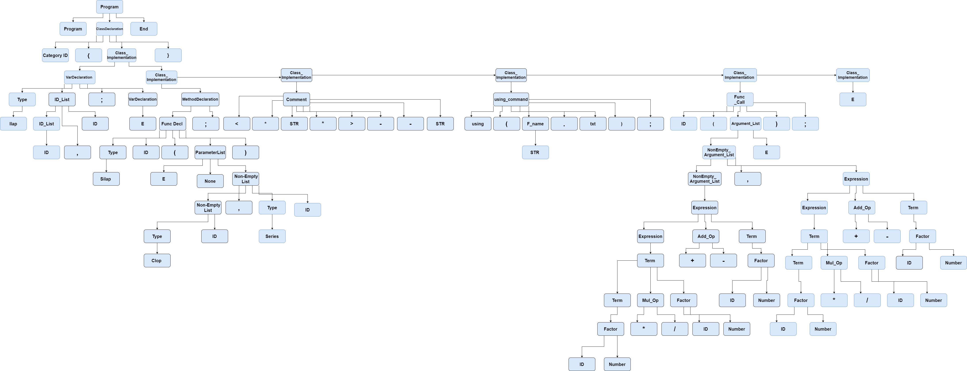

***Abstract syntax tree***

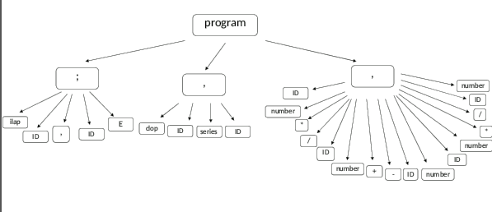

program